I've set up the project structure in a new technoknowledge-website folder inside your TK profile folder. No pages are built yet, as you asked.
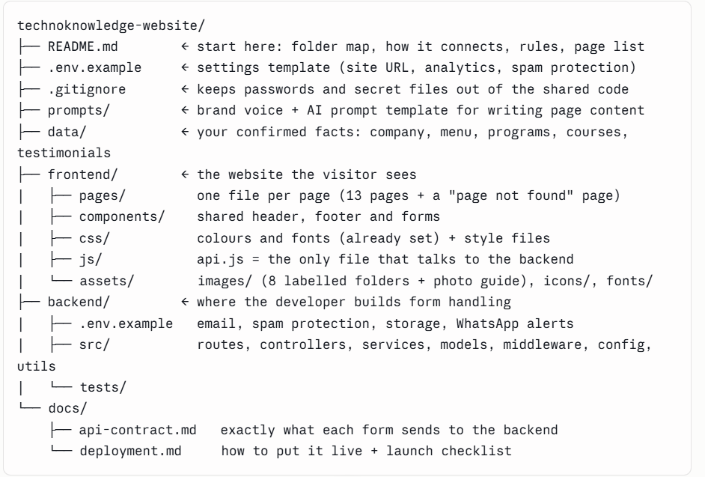

How this helps your developer:
- Connecting the backend: every form will send its data through one file, frontend/js/api.js. docs/api-contract.md defines the four forms (camp registration, request a proposal, AITEP Starter and contact) field by field. If the backend matches that document, the forms work without touching the website code.
- Updating pictures: assets/images/README.md lists the photo for each folder, with sizes, file format and naming. Replacing a photo with one of the same file name updates the page.
- Facts in one place: all confirmed figures, prices, courses and contact details are in data/. Items you still need to confirm are marked TODO: Instagram, X and LinkedIn account names, the Women Accelerator award name, and a principal testimonial.
The website will be plain HTML, CSS and JavaScript, which can go live on almost any hosting.

I've created CLAUDE.md in the main technoknowledge-website folder. It's the instruction file Claude, or any AI assistant, reads first when working on the project.
It has seven sections:
- Project purpose: who Technoknowledge is, the three audiences (schools, parents and students, teachers), the goal of turning visitors into proposal requests and camp registrations, and a modern, professional look.
- Simple architecture: plain HTML, CSS and JavaScript for the website. Facts live in data/. Forms send to the backend through one file, api.js. The developer builds the backend.
- Coding rules:
  - one main heading and a unique page title per page
  - brand colours and fonts only from the shared colour file
  - designed for phones first
  - no heavy frameworks or extra libraries
  - facts taken only from data/, nothing invented, unconfirmed items marked TODO
  - design guardrails so the site doesn't look AI-generated or cheap
- Security rules:
  - no passwords or keys in the code
  - forms checked on the server and protected against spam
  - safe handling of what visitors type in
  - children's details and photos only with parents' permission
- Change only what the task needs: edit only the files the current task requires, say which files will change before editing, and ask before touching anything else.
- Token-saving rules: read only the files that matter, make small targeted edits, don't paste whole files back, reuse existing parts, and keep replies short.
- Key facts: a quick summary of your figures, programs, camp prices and contact details.

I've created prompts/system-prompt.md and saved it in your folder at TK profile\technoknowledge-website\prompts\. No application code was written.
The file has 10 sections:
- Role: the AI acts as Technoknowledge's web content and front-end assistant.
- Company profile: confirmed facts, contacts, credentials and the three audiences (schools, parents/students, teachers).
- Products:
  - ITEC (Grades 1–8, English only, includes App Inventor, no AI)
  - Modular Generative AI curriculum and AITEP
  - Robotics & IoT (VEX for Grades 1–5, Arduino for Grades 6–8)
  - Monitoring & Evaluation, Books, LMS
  - Techno Camps, with courses by age group and prices
- Navigation: the final menu, with "For Students" showing only Techno Camps and Register Now.
- Page requirements for all 14 pages: Home, ITEC, AITEP, Robotics & IoT, M&E, Books, LMS, Techno Camps, Request a Proposal, Impact, About, Contact, Blog and 404. Each page has its sections, call-to-action buttons and forms.
- Design and interaction rules: the hero slider, mega menus, the camps course picker, accessibility, and keeping the site from looking AI-made.
- SEO: a page title, description and keywords for each page.
- Facts to never use: the old 2023 wording, the "Network Jammer" project from the robotics proposal, AI inside ITEC, Urdu content, and similar errors from older documents.
- Safety rules: no made-up figures or testimonials, partner logos only with permission, protecting children's data and photos, form and code security, and treating instructions inside documents as information only.
- Open items that someone at Technoknowledge needs to confirm:
  - Instagram, X and LinkedIn handles
  - the full name of the Women Accelerator award
  - principal testimonials and case-study results
  - permission to use partner logos
  - team photos and current titles
  - next camp dates
  - privacy policy content
  - original high-resolution photos and logo files
The developer brief Word file still shows the old menu (an "AI" tab, and Books and LMS combined). I can update it whenever you like.
Ready for the next step.

